Raphael Enyinnaya

Arnel Jerome Adviento

Manual GUI Testing

Script (Mainmenu) that controls the MainMenu GUI

* Responsible of displaying the “Play Game”, “Settings” and “Quit” buttons

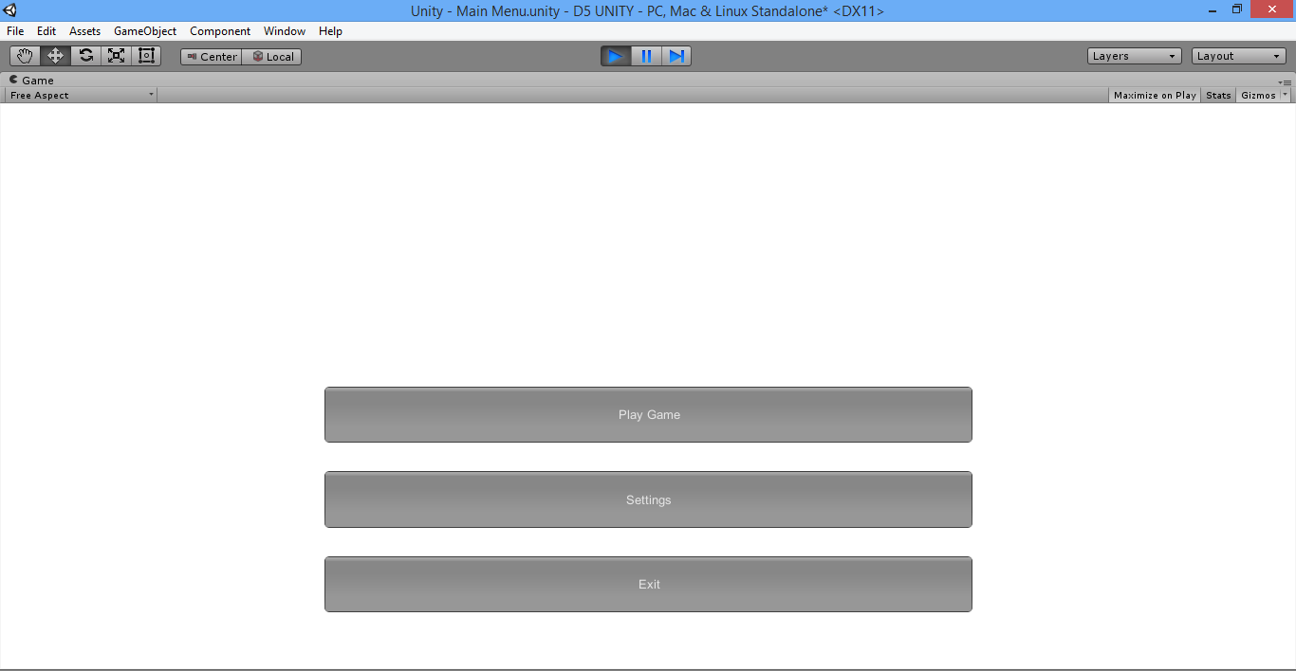

Script (Setting) that controls the Setting display

* Just displays a back button for settings (settings is not one of the features)

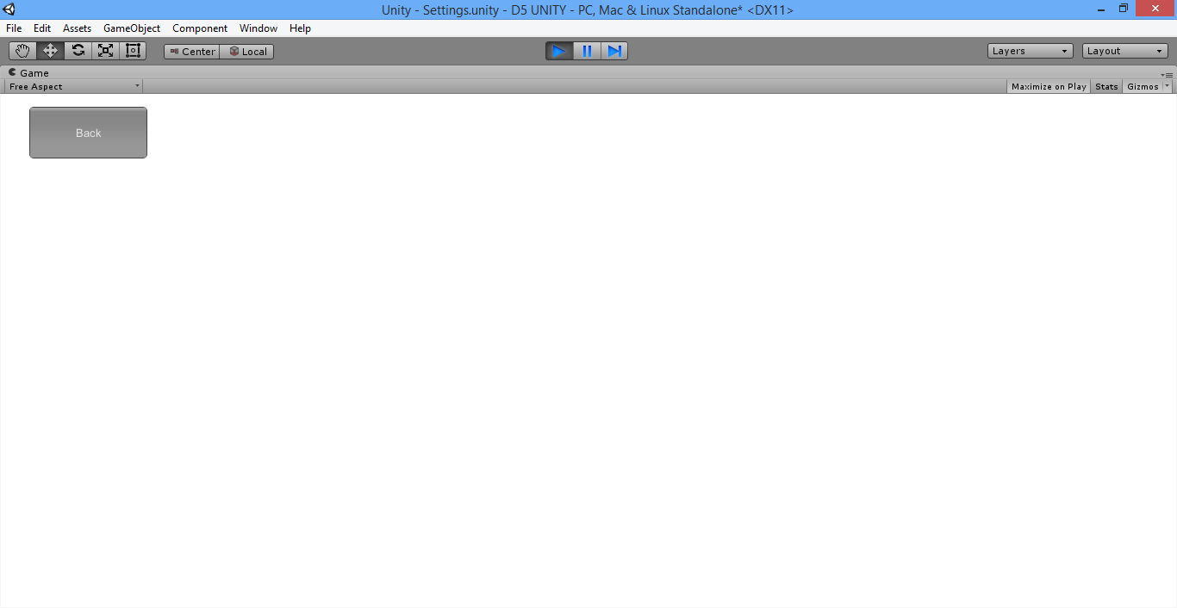

Script (InGame) that control the InGame GUI

* Updates the numbers for score and health that the player sees

